assignment 10.5

create and load :

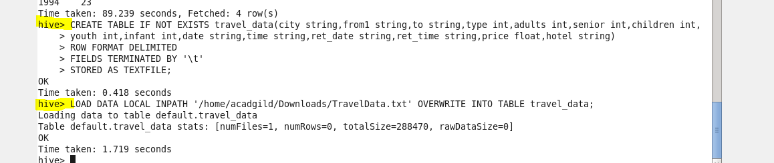

1.Write a hive query to find the top 20 destination people travel the most: Based on the given data

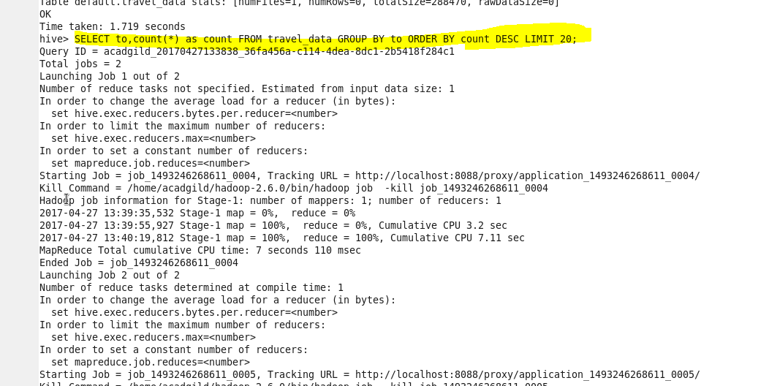

RESULT

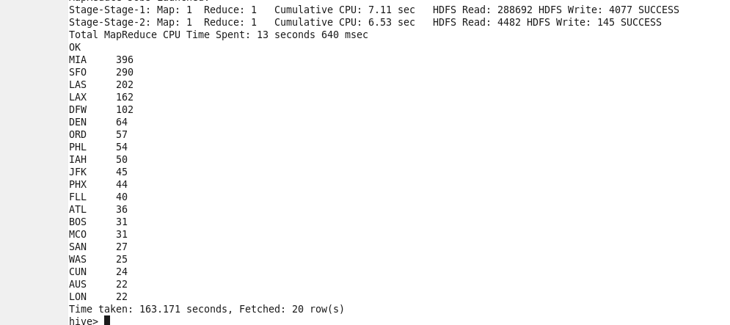

2. Write a hive query to find the top 20 locations from where people travel the most

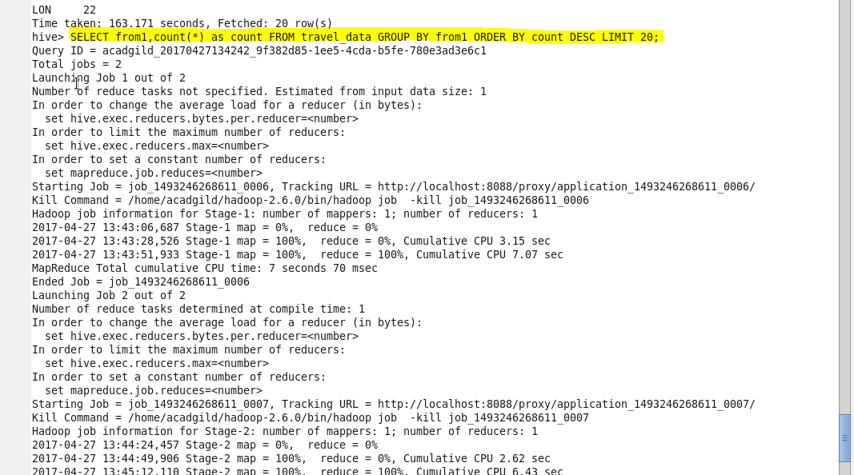

result

